ANNEX R
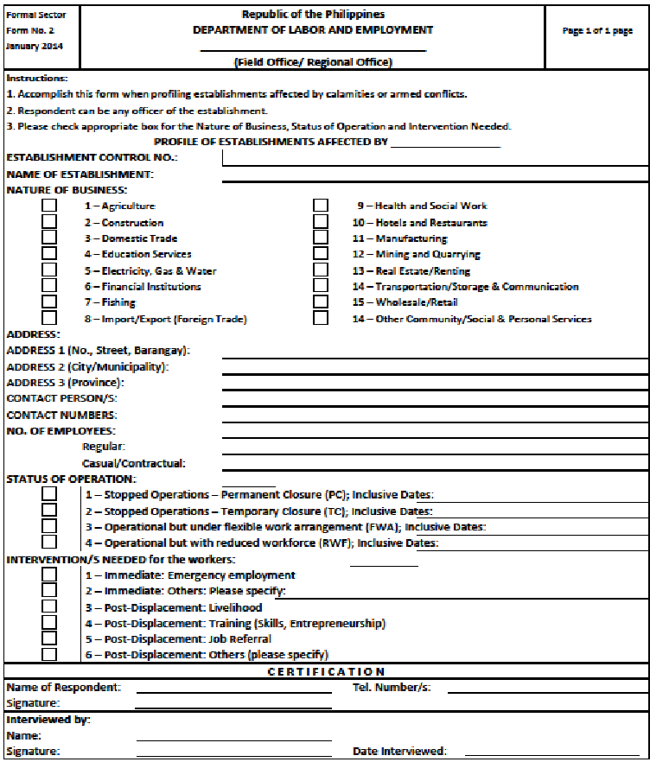
PROFILE OF ESTABLISHMENTS WITH DISPLACED WORKERS

